**ASSIGNMENT_DAY-11**

**SUBMITTED BY: M.SANJANA**

**EMPLOYEE ID: 46255357**

Q1: CREATION OF SMARTFORMS

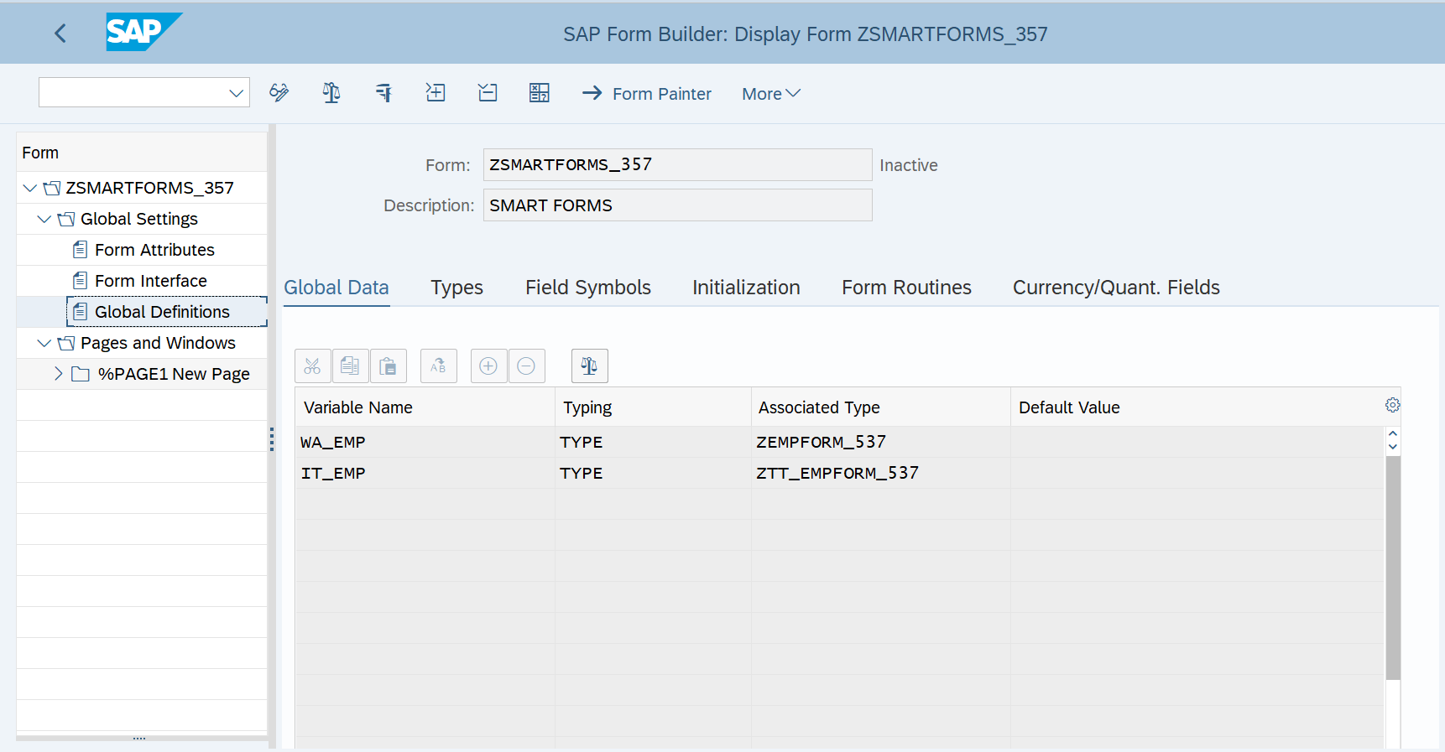

Q2: CREATION OF SMART STYLES:

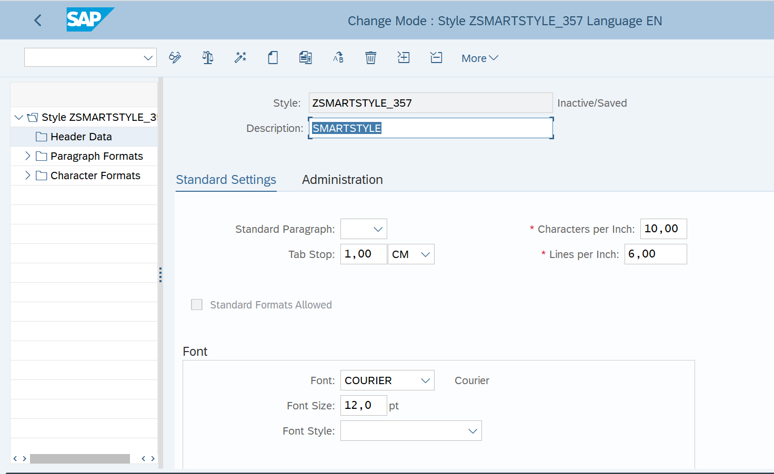

Q3: CALLING SMARTFORM FROM ABAP DRIVER PROGRAM.

REPORT Z357_DAY11_SF.  
  
data: it_emp type  ZTT_EMPFORM_357,  
      wa_emp type ZEMPFORM_357.  
  
DATA: FM_NAME TYPE RS35L_FNAM.  
  
START-OF-SELECTION.  
  
select  
  empid  
  firstname  
  lastname  
  doj  
  deptname  
  hod  
  salary  
  from Zemployyee_357 into table it_emp.  
  
  CALL FUNCTION 'SSF_FUNCTION_MODULE_NAME'  
    EXPORTING  
      formname                 = 'Zsmartforms_357'  
*     VARIANT                  = ' '  
*     DIRECT_CALL              = ' '  
   IMPORTING  
     FM_NAME                  = fm_name  
   EXCEPTIONS  
     NO_FORM                  = 1  
     NO_FUNCTION_MODULE       = 2  
     OTHERS                   = 3  
            .  
  IF sy-subrc <> 0.  
* Implement suitable error handling here  
  ENDIF.  
  
  CALL FUNCTION fm_name                         "'/1BCDWB/SF00000750'  
    EXPORTING  
*     ARCHIVE_INDEX              =  
*     ARCHIVE_INDEX_TAB          =  
*     ARCHIVE_PARAMETERS         =  
*     CONTROL_PARAMETERS         =  
*     MAIL_APPL_OBJ              =  
*     MAIL_RECIPIENT             =  
*     MAIL_SENDER                =  
*     OUTPUT_OPTIONS             =  
*     USER_SETTINGS              = 'X'  
      it_emp_sf                 = it_emp  
*   IMPORTING  
*     DOCUMENT_OUTPUT_INFO       =  
*     JOB_OUTPUT_INFO            =  
*     JOB_OUTPUT_OPTIONS         =  
   EXCEPTIONS  
     FORMATTING_ERROR           = 1  
     INTERNAL_ERROR             = 2  
     SEND_ERROR                 = 3  
     USER_CANCELED              = 4  
     OTHERS                     = 5  
            .  
  IF sy-subrc <> 0.  
* Implement suitable error handling here  
  ENDIF.

